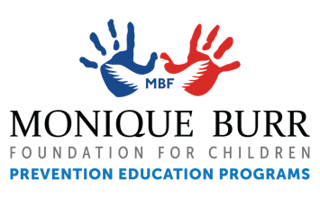
SAFETY SPIRIT WEEK!
Brought to you by the Monique Burr Foundation for Children (MBF)

DATES: [INSERT DATES HERE]

One option for presenting the MBF Child Safety Matters – Pre-K lessons is to host a Safety Spirit Week and implement one of the 5 pre-K lessons each day of the week while having children (and parents) fully engage in the lessons by participating in this “safety” themed week.

Send the following information home ahead of time with dates added to allow parents and children to prepare.
________________________________________________________________________________________

During Safety Spirit Week your child will be participating in the MBF Child Safety Matters – Pre-K lessons where they will be learning about the MBF 5 Safety Rules. We’re so excited for Safety Spirit Week, we hope you will support the scheduled activities and encourage your child to participate.

If you’d like to learn more about MBF Prevention Education Programs and the 5 Safety Rules, visit www.mbfpreventioneducation.org.
________________________________________________________________________________________
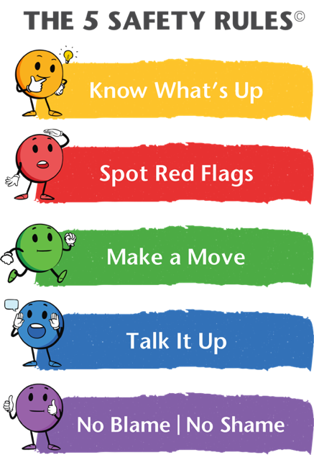
MONDAY: Safety Rule #1 - Know What's Up.
You are bright and you “KNOW WHAT’S UP” – Wear bright/neon colors.

Know What’s Up helps us understand general safety information, to learn our personal information such as parents names, address and important phone numbers, and how to get help in an emergency.

TUESDAY: You can “SPOT RED FLAGS” – Wear the color red and/or bring in a red item for show and tell.
Safety Rule #2 is Spot Red Flags. Spot Red Flags teaches us to look for warning signs or clues that someone or something may be unsafe. Red flags are when you see something unsafe, or you see someone being hurtful with either words or actions.

WEDNESDAY: If you are not safe, “MAKE A MOVE” – Wear your favorite sports jersey or sports team shirt/colors.
Safety Rule #3 is Make a Move. Make a Move encourages us to get away and stay away from unsafe situations or people. If we Spot Red Flags, you can walk away, run away, or do whatever you can to get away from people or situations you know are not safe.
DOWNLOAD THE NEW MBF CHILD SAFETY MATTERS MOBILE APP!

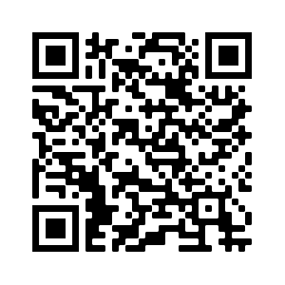
THURSDAY: “TALK IT UP” with a Safe Adult – Dress like one of your safe adults.
Safety Rule #4 is Talk It Up. Talk It Up means knowing we have a right to be safe and you can use a strong or assertive voice if you or others are in an unsafe situation. You can Talk It Up by reporting to a Safe Adult about unsafe or inappropriate situations or behaviors. Students are taught that a Safe Adult is an adult that you can go to if you ever feel unsafe.

FRIDAY: If you are ever hurt, there is “NO BLAME | NO SHAME” – Dress as your favorite superhero and/or bring you favorite hero action figure for show and tell.
Safety Rule #5 is No Blame | No Shame. No Blame | No Shame teaches us no matter what happens, or what has happened in the past, it is important to know you should never feel ashamed to seek help and talk to a Safe Adult if you are unsafe or have been hurt.

