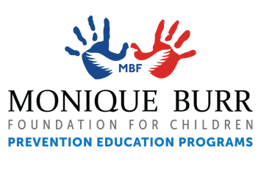
SAFETY SPIRIT WEEK!
Brought to you by the Monique Burr Foundation for Children (MBF)

DATES: [INSERT DATES HERE]

October is Bullying Prevention Month! This week, help promote awareness of bullying prevention by participating in Safety Spirit Week. During Safety Spirit Week your student will have the opportunity to show their school spirit to help reinforce the MBF 5 Safety Rules© taught during MBF Teen Safety Matters® lessons at school. The 5 Safety Rules are strategies that help youth and teens to recognize, prevent, and respond appropriately to unsafe situations such as abuse, relationship abuse, bullying, cyberbullying, and digital dangers. We’re so excited for Safety Spirit Week, we hope you will help support and encourage your student to participate.

If you’d like to learn more about MBF Prevention Education Programs and the 5 Safety Rules, visit www.mbfpreventioneducation.org.
________________________________________________________________________________________
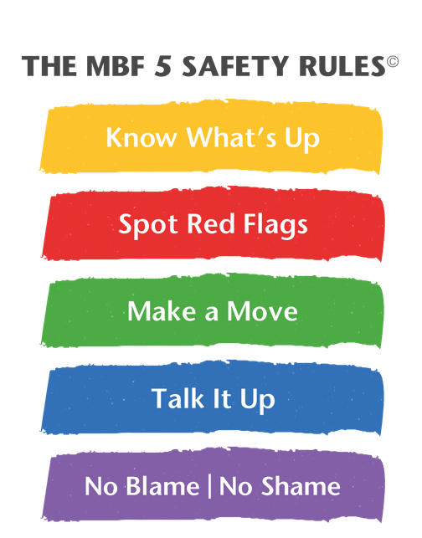
MONDAY: KNOW WHAT’S UP – Wear the color yellow.
Safety Rule #1 is Know What's Up. Knowing What’s Up means we are aware of our environment and the people around us, both online and off. It also means knowing important contact information such as your parent’s and Safe Adults’ cell phone numbers in case you lose your phone or how to get help in an emergency.

TUESDAY: SPOT RED FLAGS – Wear the color red.
Safety Rule #2 is Spot Red Flags. Spotting Red Flags means using your awareness of safe versus unsafe situations to determine if someone’s behavior or a social interaction, online or off, is unsafe or inappropriate.

WEDNESDAY: MAKE A MOVE – Wear the color green.
Safety Rule #3 is Make a Move. Making a Move involves using good decision-making skills to respond to new or unsafe situations, both online and off. You can Make a Move by “getting away” from unsafe situations or people if possible, or by staying away from people and situations you know are not safe.

THURSDAY: TALK IT UP – Wear the color blue.
DOWNLOAD THE NEW MBF CHILD SAFETY MATTERS MOBILE APP!

Safety Rule #4 is Talk It Up. Talking It Up means knowing we have a right to be safe and you can use an assertive voice if you or others are in an unsafe situation, online or off. You can Talk It Up by reporting to a Safe Adult about unsafe or inappropriate situations or behaviors. Students are taught that a Safe Adult is an adult that you can go to if you ever feel unsafe and that not reporting allows problems to continue to grow and may cause more damaging long-term consequences.

FRIDAY: NO BLAME | NO SHAME – Wear the color purple.
Safety Rule #5 is No Blame | No Shame. No Blame | No Shame teaches us that no matter what happens, or what has happened in the past, it is important to know you should never feel ashamed to seek help and talk to a Safe Adult if you are unsafe or have been hurt. Students are taught talking to a Safe Adult can help them learn and stay safe.

